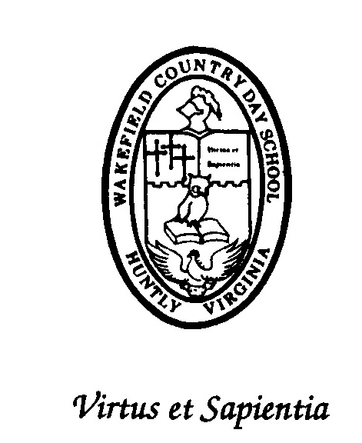
WCDS Academic Profile
Wakefield Country Day School

Jennifer Thede John Elmore

College Advisor Head of School

1059 Zachary Taylor Hwy * PO Box 739 * Flint Hill, VA * 22627
College Counseling Office  (540) 635-8555 Ext. 225  www.wcdsva.org

CEEB CODE: 472332

THE SCHOOL

Wakefield Country Day School (WCDS) is a pre-school through twelfth-grade college preparatory school whose curriculum emphasizes scholarship in the classical tradition. Situated about ninety minutes outside Washington, D.C., on a twelve-acre rural campus in Rappahannock County, Virginia, the school draws students from and provides bus transportation to its surrounding eight counties. International students also attend WCDS at the high school level and live with host families or on campus at Trinity Manor with a faculty member’s family.

WCDS prides itself on offering an education designed to produce students who write well, possess strong analytical skills, and demonstrate well-developed ethical responsibility. The school lives up to its motto of Virtus et Sapientia (Virtue and Wisdom) by fostering an ethic of individual worth, service, and personal responsibility to prepare its graduates for the moral and intellectual rigors of citizenship in the twenty-first century. Its mission is to develop each student’s character and intellect through active involvement in a structured curriculum founded on classical principles and in an environment that encourages scholarship, diligence, self-discipline, and respect for and service to others.

WCDS is accredited by the Virginia Independent School Association, whose accreditation process has been approved by the Virginia Council for Private Education Committee on Accreditation as authorized by the Virginia State Board of Education.

THE ACADEMIC PROGRAM

All Upper School students take a demanding, honors-level course load, and student electives can be tailored to fulfill the requirements of the diploma offered. The WCDS Classical Diploma requires completing 32 credits. Possible areas of concentration include mathematics, history, language, and science. All exceed Virginia’s mandate of 23 credits for graduation. Each of these courses of study requires completion of at least:

English 5 Credits
Ancient Language 2 Credits
Modern Foreign Language 3 Credits
History & US Government 4 Credits
Finance and Senior Thesis 1 Credit
Science 4 Credits
Mathematics 4 Credits
Fine Arts 1 Credit
General Elective 5 Credits
PE/ Competitive Teams 3 Credits

WCDS also offers an International Studies Diploma (23 credits) designed to meet the needs of those in the international boarding community who enter WCDS after the tenth grade.

The school day at WCDS consists of eight 45-minute class periods held Monday through Friday. Most students take seven or eight academic courses per day. Semester grades reflect two-quarter grades plus the semester exam. Because of its size, WCDS does not rank its students but does compute cumulative academic grade point averages at the end of each year for grades 9 -12.

WCDS Grading Scale/Unweighted GPA
97%-100% | A+ | 4.0 | 78%-79% | C+ | 2.3
90%-96% | A | 4.0 | 73%-77% | C | 2.0
88%-89% | A- | 3.7 | 70%-72% | C- | 1.7
87% | B+ | 3.3 | 69% | D+ | 1.3
83%-86% | B | 3.0 | 66%-68% | D | 1.0
80%-82% | B- | 2.7 | 65% | D- | 0.7
64% and below F

ADVANCED PLACEMENT OFFERINGS

Depending on the year, WCDS offers Advanced Placement Courses in Calculus AB and BC, English Language, English Literature, Environmental Science, Modern European History, Latin, Spanish, Statistics, Comparative Government, and U.S. Government. Two classes (US History and Environmental Science) are offered as Dual Enrollment for college credit through Laurel Ridge Community College. Additional online AP courses are an option for students as well. Consistently, WCDS seniors receive recognition as AP Scholars.

Standardized Test Score Averages for 2022, 2023 and 2024

 | Class of 2022 | Class of 2023 | Class of 2024
SAT Composite Average | 1230 | 1204 | 1293
SAT ERW Average | 600 | 640 | 692
SAT Math Average | 630 | 564 | 602

COLLEGE ACCEPTANCES

100% of Wakefield Country Day School graduates apply to and are accepted by selective four-year colleges and universities, collectively receiving one and two million dollars in merit scholarships annually. Schools to which recent graduates have been accepted include, but are not restricted to:

American University, Boston College, Boston University, Bryn Mawr College, Clemson University, College of William & Mary*, Colorado State University, Connecticut College, Corcoran School of Art and Design, Cornell University, Dartmouth College, Davidson College, Duke University, Emerson College, Emory University, Fordham University, Franklin and Marshall, Furman University, George Mason University, George Washington University, Gettysburg College, Hampton Sydney College, Haverford College, Indiana University, Ithaca College, James Madison University*, Kelley School of Business-IU, Lafayette College, Lehigh University, Loyola University, McGill University-Canada, Miami University-Ohio, Michigan State University, Mount Holyoke College, New York University, NYU-Abu Dhabi, Oberlin College, Ohio State University, Pennsylvania State University, Princeton University, Purdue University, Randolph Macon College, Rensselaer Polytechnic Institute, Pratt Institute of Art, Rochester Institute of Technology*, Rutgers University, St. Andrews University-Scotland, Smith College, Swarthmore College, Trinity College, Tulane University, University of Alabama, University of Arizona, Universities of California-Davis and San Diego, University of Charleston, University of Chicago, University of Colorado Boulder, University of Connecticut* University of Georgia, University of Mary Washington*, University of Massachusetts Amherst, University of Minnesota, University of New Castle Australia, University of North Carolina-Chapel Hill, University of Pittsburgh, University of Richmond, University of Southern California, University of Virginia*, University of Toronto-Canada, University of Vermont*, University of Wisconsin, Vanderbilt University, Vassar College, Virginia Commonwealth University, Virginia Tech*, Wake Forest University, West Virginia University, Worcester Polytechnic Institute*, and Yale University.
* Students offered entrance into Honors College programs including Echols Scholar Program at UVA and Monroe Scholars at William and Mary
Faculty College Degrees
The colleges and universities from which current WCDS faculty/staff have earned degrees include, but are not limited to: American University; Brigham Young University; Bryn Mawr College; Clemson University; Corcoran School of Art and Design, Georgetown University of Law; Indiana University; James Madison University; Lewis and Clark Law School; Marymount University; New York University; Old Dominion University; Pennsylvania State; Rhode Island School of Design; San Francisco Academy of Art; Shenandoah University; Smith College; University of Mary Washington; University of Pennsylvania; University of Virginia; Texas A&M University-Kingsville; Virginia Commonwealth University; Virginia Tech; and Williams College.

100% of academic faculty have AB, BA, and/or BS degrees; 36% have master’s degrees; 12% have earned doctorates.

